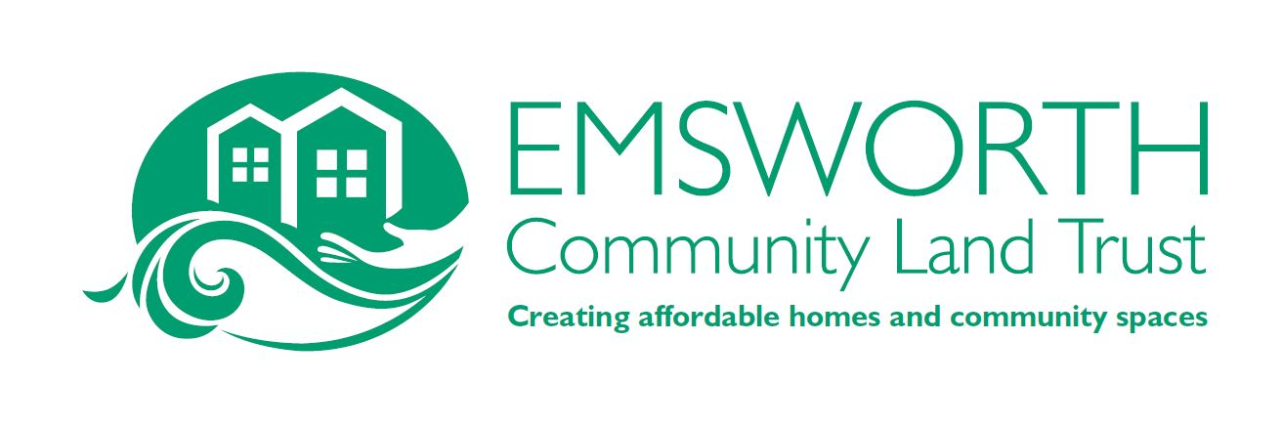

Report from the Chair & Directors for 2021-22 (AGM 29 October 2022)
This is our fifth year of operating as a Community Land Trust. But, as with many other groups, it has been slow to recover momentum post Covid.
Our work as a Land Trust has been limited, as has our engagement with members. We have kept in touch with members through newsletters and have kept our new website uptodate.

We are still seeking a response from Havant Borough Council (HBC) on the agreement for the new early years, youth and community centre for Emsworth that we have been instrumental in helping develop. But there has been no action or clear response from HBC as to why a lease has not been agreed with the providers of the new centre, YMCA.
The ECLT has developed a working sustainable model for development. Again, we have been unable to get a clear response from HBC although early in the year a discussion on the model was held. With the 'new' single council coming into place we are hoping for greater traction with new personnel coming in to HBC.
We were delighted to work with the Emsworth Neighbourhood Forum and to support the passing of the Neighbourhood Plan.
Dwynwen Stepien (Chair)
Objective 1 – Affordable Housing
We had hoped that a gradual return to pre-covid normality would bring with it fresh opportunities for community-led housing in Emsworth. Various prospects for partnering with HBC to release underutilised public land have been investigated but no serious candidates have survived detailed analysis so far. It may prove to be the case that the CLT model for housing is not viable in Emsworth without something extraordinary such as a gift of land from a benefactor. We are not calling time on affordable housing however and remain vigilant to any opportunities that present themselves.
Mike Ridley Director

Objective 2: Youth and Community Space

We remain committed to improving activities for young people in Emsworth but are clearly frustrated by the lack of movement on the proposed early years, youth and community centre at Redlands Grange. If an agreement was signed we could pursue our plans for consultations with young people and help- to push the project forward.
Ellie Turnbull, Director

Objective 3: Maintaining and generating a thriving town centre and business
Community

The ECLT has been working closely with the Forum and the ERA to achieve this objective, and based on the Neighbourhood Plan and other public consultations we have developed a list of projects that we wish to achieve soon.

Modifying the town square and the high street to make it more pedestrian friendly
Developing South Street to improve facilities, including the public toilets.
Making North Street more pedestrian friendly and safer to cross.
Together these would make the town centre a more attractive place in which to spend time, to the benefit of our businesses.

Since the Neighbourhood plan was approved, we have been able to have constructive discussions with HBC and their officers to help take these forward.
In the longer term we would like to see some solutions to traffic on the A259 to make it safer, particularly for cyclists, and to minimise the way that it currently divides the town.

We are aware that the voice of the business community is not adequately represented, and intend to help rectify this soon.

Theo Schofield, Director

